Task 1

Windows is already installed and setup

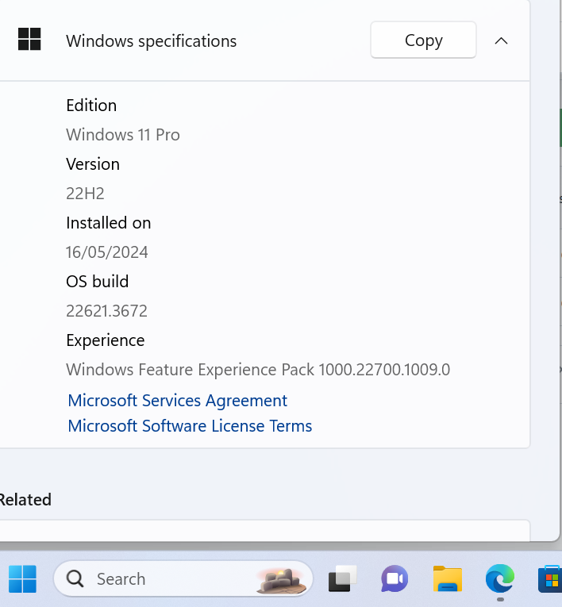

Task 2

Already installed Visual studio code

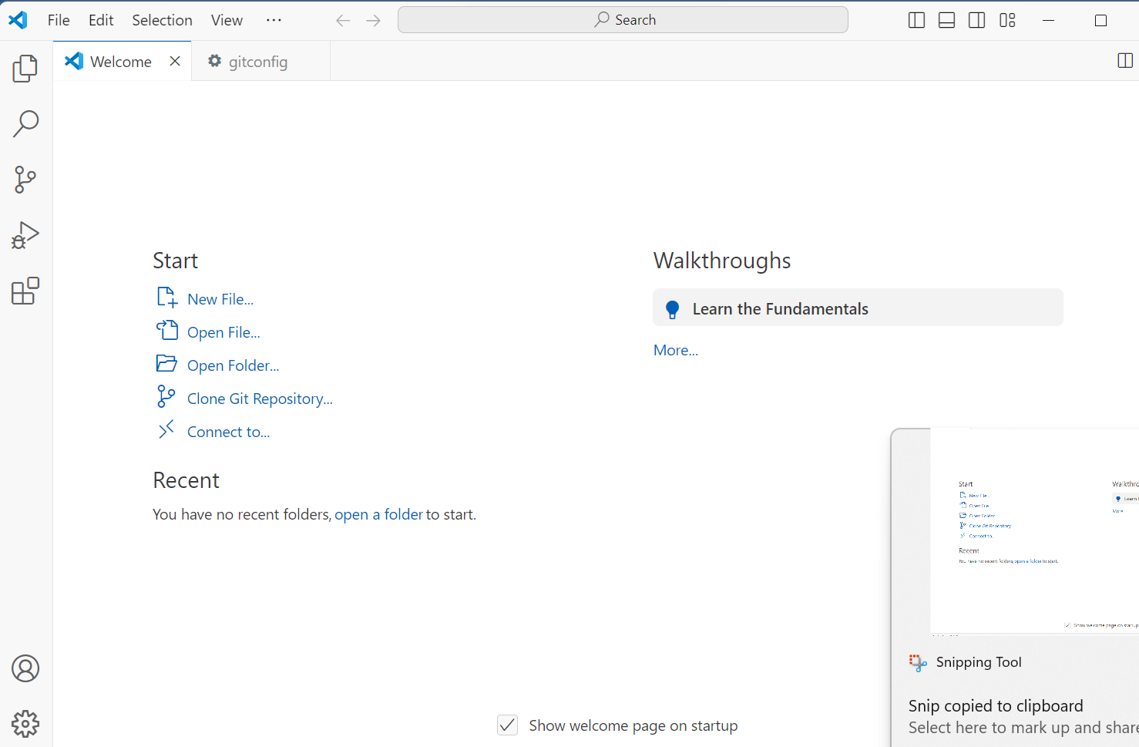

Task 3

To install Git Bash on your PC, follow these steps: First, go to the official Git website (https://git-scm.com/) and download the installer for Windows. Once downloaded, run the installer. During installation, you can choose the default options unless you have specific preferences to configure. Git Bash is typically included as part of the Git for Windows package, so ensure that option is selected during installation. After installation completes, you can launch Git Bash from the Start menu or desktop shortcut. Git Bash provides a command-line interface that allows you to use Git and Unix tools on Windows, making it easier to work with version control and software development projects.

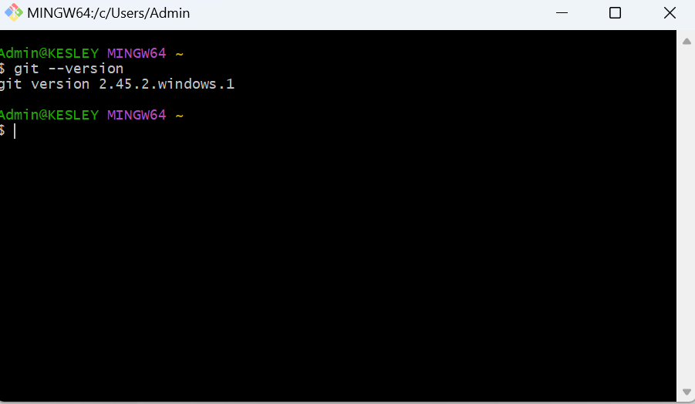

Task 4

To install Python on Windows, begin by downloading the installer from the official Python website. Once downloaded, run the installer executable and ensure to select the option to "Add Python to PATH" during the installation process. This step is crucial as it allows Python to be accessed from any command prompt window without specifying its full installation path each time. After installation, open a new command prompt window and type `python --version` to verify that Python is correctly installed and configured in the system's PATH. If Python is recognized and displays its version number, it confirms successful installation and PATH configuration.

In cases where you need to manually add Python to the PATH, navigate to the system's Environment Variables settings through "Properties" > "Advanced system settings" > "Environment Variables" in the Control Panel. Edit the `Path` variable under "System Variables" and append the path to the Python installation directory (e.g., `C:\Python39`). This ensures Python is globally accessible across your system. Verify the manual configuration by opening a new command prompt window and checking Python's version with `python --version`. Following these steps ensures Python is properly installed and integrated into your development environment on Windows.

Task 5

To configure MySQL on Windows, begin by downloading the MySQL Installer from the official MySQL website. After downloading, run the installer executable to launch the MySQL Installer wizard. During the installation process, select "Custom" setup to choose components such as MySQL Server, MySQL Workbench (optional GUI tool), and other necessary components. Follow the wizard's prompts to configure MySQL Server settings such as port number, root password, and service configuration. Ensure to choose a strong password for the root user and configure the MySQL Server to run as a Windows service for automatic startup. Once installation is complete, MySQL Server should be running and accessible through MySQL Workbench or command-line tools like MySQL Command Line Client for further configuration and database management tasks. To configure MySQL on Windows, begin by downloading the MySQL Installer from the official MySQL website. After downloading, run the installer executable to launch the MySQL Installer wizard. During the installation process, select "Custom" setup to choose components such as MySQL Server, MySQL Workbench (optional GUI tool), and other necessary components. Follow the wizard's prompts to configure MySQL Server settings such as port number, root password, and service configuration. Ensure to choose a strong password for the root user and configure the MySQL Server to run as a Windows service for automatic startup. Once installation is complete, MySQL Server should be running and accessible through MySQL Workbench or command-line tools like MySQL Command Line Client for further configuration and database management tasks.